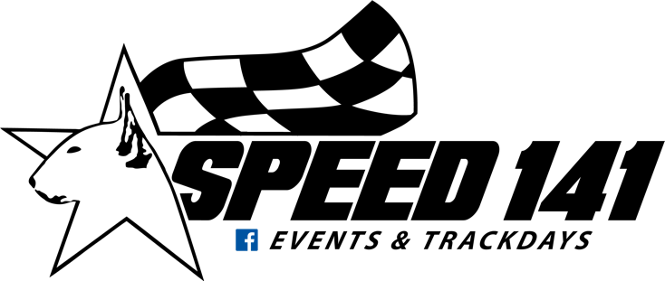

DISCHARGE OF RESPONIBILITY

I, the undersigned,
Name and first name of the participant: ..........................................................................................
Address :……………………………………………………………………………………………………………………………………...
Cell phone: ………………………………………………………………………………………………………………………………….
E-mail :……………………………………………………………………………………………………………………………………......
Vehicle: ...............................................................................................................................................
Registration: ........................................................................................................................................

By signing this document, I hereby release the organizer of any responsibility during the event organized by SPEED 141, in particular during the track day at the circuit of “ Les Ecuyers” taking place on ………………………………. (Date of your Trackday)
I waive any claims of any nature whatsoever in the event of an accident, injury, theft, damage to personal property or other things occurring during my participation in the event named above.
I acknowledge that I am aware of the fact that the event named above is in no way a sporting event and I undertake to respect the rules of the road.
I am informed that it is my responsibility to personally take out liability insurance and insurance for my vehicle. I am also a financial guarantor in case of voluntary degradation that I could cause during this event.
The refusal to sign this release of responsibility or the non-presentation of this, reserves the organization the right to exclude my participation in the event.
Done at ………………………………… on ………………………………..

Signature:
Read and approved.

